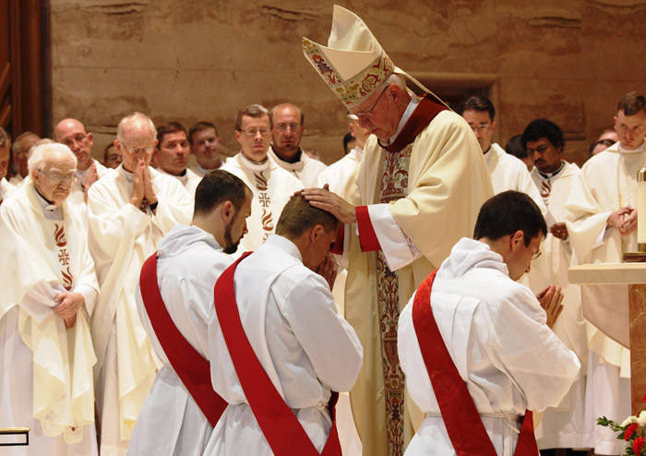The
End Time
Devotions

for
Priests & Clergy

Weapon of Prayers given by Heaven to help God’s sacred servants to remain firm and True to the Faith during the trials and persecutions that lead up to the Second Coming of Christ.

The 3 End Time Devotions
in the Spiritual Battle
for the Salvation of Souls.

- The Holy Rosary ( for protection against demonic attacks )
- The Divine Mercy Chaplet ( for spiritual conversion of the human race)
- The Crusade of Prayers ( for the Spiritual Battle for Souls )

TABLE OF CONTENTS

 | How to pray the Holy Rosary
 | How to Pray the Divine Mercy Chaplet
CP22 | Catholic Church to uphold the Teachings of the Church
CP33 | To acknowledge the Seal of the Living God
CP40 | Prayer for the Clergy, for preparing souls for the Second Coming
CP49 | Pledge of loyalty for Christian Clergy
CP56 | Priests seeking Protection for the Holy Eucharist
CP57 | Prayer for the Clergy – Jesus let me hear Your call
CP66 | For clergy: Help me to remain true to Your Most Holy Word
CP70 | Prayer for Clergy to remain firm and true to the Holy Word of God
CP86 | Release me from the torment of doubt
CP110 | For Priests to remain true to Your Holy Word
CP114 | For Priests to receive the Gift of Truth
CP123 | Gift of Free Will to God
CP135 | To defend the Truth
CP125 | To defend the Most Holy Word of God
CP170 | To uphold the Holy Word of God

HOW TO PRAY THE ROSARY
Prayer Before the Rosary
Queen of the Holy Rosary, Thou didst deign to come to Fatima to reveal to the three shepherd children the treasures of grace hidden in the Rosary. Inspire my heart with a sincere love of this devotion, in order that by meditating on the Mysteries of our Redemption which are recalled in it, I may be enriched by its fruits and obtain peace for the world, the conversion of sinners and of Russia, and the graces which I ask of Thee in this Rosary. (Here mention your request.) I ask this for the greater glory of God, for Thine own honor, and for the good of souls, especially for my own. Amen.
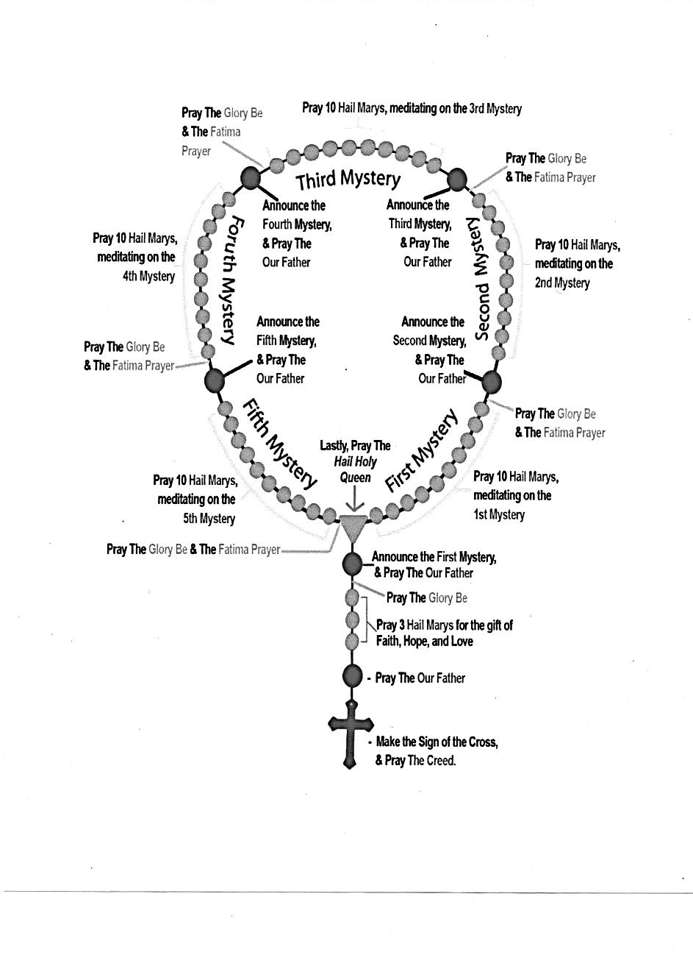

Excerpts from the Book of Truth about the Holy Rosary:

“Never forget the importance of my most holy Rosary because when you say it every day you can help save your nation.

Satan’s power is weakened when you say my Rosary. He runs away in great pain and becomes powerless. It is most important, no matter what Christian faith you belong to, to say this at least once a day”

HOW TO PRAY THE DIVINE MERCY CHAPLET
- Our Father
- Hail Mary
- Apostle’s Creed
- (#6, #8, #10, #12)
(on the 5 White beads...)
Eternal Father, I offer you the Body and Blood, Soul and Divinity of your dearly beloved Son, Our Lord Jesus Christ, in atonement for our sins and those of the whole world.

- (#7, #9, #11, #13)
(on each 10 small beads …)
For the sake of his sorrowful Passion, Have Mercy on us and on the whole world.

14. Holy God, Holy Mighty One, Holy Immortal one, Have Mercy on us and on the whole world. (3x) Amen.
JESUS, King of Mercy, I trust in You

10.
9.
11.
8.
7.

12.
6.
5.
13.
14.
4.
3. Apostle’s Creed
2. Hail Mary
1. Our Father

Prayer for Encouragement
(Received 10 May 2011 16.00 hours)

My Mercy, as I have said, knows no bounds. Filled now with the Spirit of light and holiness you, all My followers everywhere, must be brave now and proclaim My word to all you come into contact with. Dismiss the scorn you may experience for it is too important now to ignore My pleas for conversion. Hear My prayer now to give you the encouragement you need:

“Fill me now O Lord with the gift of the Holy Spirit to carry Your most Holy Word to sinners who I must help save in Your name. Help me to cover them, through my prayers, with Your precious Blood so that they can be drawn to Your Sacred Heart. Give me the gift of the Holy Spirit so that these poor souls can revel in Your New Paradise.”

Say this prayer every day after you recite My Divine Mercy and you, through your allegiance to Me, will help save My children. Your Jesus

Crusade of Prayer (22)
Catholic Church to uphold the Teachings of the Church
Friday, January 27th, 2012 @ 23:50

You are my true disciples and I must urge you to take up your weapons to save My Church. This very Church, founded on the Rock, by My beloved disciple, Peter, will never fail.
The enemy may believe it to be destroyed, but that would be a foolish assumption.
No one will, or can, destroy My Church. Out of the ashes it will rise to proclaim My Glory, as I come back to salvage My Kingdom on Earth. You must never desert Me, your beloved Saviour, ever.
For without Me, there is no Light. Without Light, there is no future.
My daughter, I give the world this Crusade of Prayer, for the Catholic Clergy to recite.
O my beloved Jesus, keep me strong and the flame of my love for You alight, every moment of my day. Never allow this flame of love for You to flicker or die. Never allow me to weaken in the presence of temptation.
Give me the Graces needed to honour my vocation, my devotion, my loyalty and to uphold the Teachings of the orthodox Catholic Church.
I offer you my allegiance, at all times.
I pledge my commitment to fight in Your Army, so that the Catholic Church can rise again in glory, to welcome You, dear Jesus, when You come again. Amen.
Your beloved Saviour
Jesus Christ

Crusade Prayer (33)
To Acknowledge Seal of the Living God
Monday, February 20th, 2012 @ 12:20 pm

O My God, My loving Father, I accept with love and gratitude Your Divine Seal of Protection.

Your Divinity encompasses my body and soul for eternity. I bow in humble thanksgiving and offer my deep love and loyalty to You my Beloved Father.

I beg you to protect me and my loved ones with this special Seal and I pledge my life to Your service forever and ever.

I love you Dear Father, I console You in these times Dear Father.

I offer You the Body, Blood, Soul and Divinity of Your dearly beloved Son, In atonement for the sins of the world and for the salvation of all Your children. Amen.

My Seal is My promise of Salvation. My Power will surge through you, with this Seal, and no harm will come to you. This is a miracle, children, and only those who bow before Me, their Lord and Creator of all things, as little children with love in their hearts for Me, can be blessed with this Divine Gift.

Your loving Father in Heaven
God of the Most High

God the Most High (Thursday, March 8th, 2012 @ 07:52 pm ) : “Children do not be afraid. No harm will come to those who wear My Seal, the Seal of the Living God. Satan and his fallen angels, who infest the world at this time, do not have the authority over those who have the mark of the Living God. You must listen to Me children and accept My Seal, for it will save not only your lives but your souls.”

“Recite the prayer to receive My Seal every day.”

Crusade Prayer (40)
Prayer for the Clergy, for preparing souls for the Second Coming
Saturday, March 24th, 2012 @ 11:45
You must ask Me to cover you with My Holy Spirit for discernment with humility and purity of soul.
When you do, I will reveal to you the Truth of My Most Holy Word, given to you now through this prophet. After that, it will be your duty to ensure that all those souls who look to you for guidance, are helped to prepare their souls for My Second Coming.

Never be afraid to utter the phrase “The Second Coming of Christ”, for many of My flock do not know what it means.

So few of them have been taught about this Great and Glorious Event, or the importance of preparing their souls so that they are in a State of Grace. Never be afraid to preach about the existence of Purgatory or Hell. It is your responsibility to tell My people the Truth. Look to Me for guidance through this prayer:
O my Jesus, I am but a humble servant and need You to guide me, so I can prepare souls for Your Glorious Second Coming.
Help me to convert souls and prepare them according to Your Holy Will so that they are fit to enter the New Heaven and Earth, which You promised all of mankind, through Your death on the Cross.
Give me the Graces I need so that I can impart Your Word to thirsty souls and that I never waiver in my duty to You, dear Jesus, to Whom I pledged my allegiance through my sacred vows. Amen.
Go now My sacred servant and accept the role for which you were chosen.
The challenge of preparing souls for My Second Coming is the biggest ever in your ministry and you must accept this with love and joy in your hearts.
Accept also the Gift of being chosen as a sacred servant in these, the end of times, when the New Heaven and Earth emerges as My New Paradise.
You are blessed to be living in these times.
Your Beloved Jesus
Crusade Prayer (49)
Pledge of loyalty for Christian Clergy
Tuesday, April 24th, 2012 @ 19:45

Go now My sacred servant and accept the role for which you were chosen.
Prayer is your route back into My Arms.
Pray, pray, pray for the Graces to open your eyes, so that you can recognise Me before it is too late.
I need your help, your love and your loyalty.
Remember, it was because of Me that you took your sacred vows. Now that I call out to you, do not reject Me.
Embrace Me and allow Me to guide you, so that you can lead My Remnant Church and salvage souls.
I give you My special blessing and await you to respond to My Call as follows in this:
O Jesus, I am Your humble servant. I pledge my love and loyalty to You. I beg You to give me a sign of Your calling. Help me to open my eyes and witness Your promise.
Bless me with the Grace of the Holy Spirit, so that, I will not be deceived by those who claim to come in Your Name, but who do not speak the Truth. Show me the Truth.
Allow me to feel Your Love so that I can fulfill Your Most Holy Will. I ask You, with a humble heart, to show me the way, in which I can help You to save the souls of humanity. Amen.
Do not ignore My Call. Do not reject Me when I come once more.
This time I come not only to save mankind once more, but to fulfil the Divine Will of My beloved Father, God the Most High.
Go in peace.
Your beloved Jesus
Crusade Prayer (56).
Priests seeking Protection for the Holy Eucharist
Tuesday, April 24th, 2012 @ 19:45
Follow Me. This is the greatest challenge you will ever have to face but I will give you the Graces to discern the truth from the sacrilegious fiction you will be asked to accept in My Holy Name.
You must ask for My Help now through this:
O Dear Father, in the name of your Precious Son, who sacrificed Himself on the Cross for the whole of mankind, help me to stay true to the Truth.
Cover me with the Precious Blood of Your Son and give me the Graces to continue to serve You in faith, trust and honour for the rest of my ministry.
Never let me stray from true meaning of the Sacrifice of the Holy Mass or the presentation of The Holy Eucharist to Your children.
Give me the strength to represent You and feed Your flock the way in which they must be fed with the Body, Blood, Soul and Divinity of Your Son, Jesus Christ, The Saviour of Mankind. Amen.

Please know that I walk with each of you, My Beloved Sacred Servants, every day.
I hold you up. Lean on Me and I will keep you close to My Sacred Heart in these times of terrible torment within the Catholic Church.

Your Beloved Jesus

Crusade Prayer (57)
Prayer for the Clergy – Jesus let me hear your call
Monday, May 28th, 2012 @ 08:45 pm

Do you remember the first time I called you? You felt My voice speaking to your soul urging you to join in union with Me. Can you hear Me now?
Ask Me to reveal to you now, that it is I, your Jesus begging you to come, rise and follow Me on this last arduous journey to Eternal Life. Do not fear My Call. Trust Me and say this prayer asking Me to let you hear My call.
O my dear Jesus, open my ears to the sound of Your Voice. Open my heart to Your loving call. Fill my soul with the Holy Spirit So I can recognize You at this time.
I offer You my humble allegiance to all that You ask of Me. Help me to discern the Truth, rise, respond and
follow your voice so I can help You to save the
Souls of all of humanity.
Your will is my command Give me the courage to let You guide me So I can take up the armour needed to lead Your
Church towards Your New Kingdom. Amen.
Remember, I Jesus Christ, will never allow My Sacred Servants to wander off the Path of Truth. I will stand at every corner, every avenue and point you in the right direction.
You may find this frustrating at times. You may be confused. You may not want to hear the Truth. You may be fearful. But know this.
I will always love you. I will always be at your side.
I will never desert you.
Your beloved Jesus

Crusade Prayer (66)
For clergy: Help me to remain true to Your Most Holy Word
Monday, July 16th, 2012 @ 03:15 pm

The time will come when My Church will divide, one side against the other.
I call on all of My sacred servants to remember your most holy vows.
Never forsake your mission. Never forsake Me. Never accept lies in lieu of the Truth.
You must ask Me to help you in the difficult times ahead. You must rise, unite and follow Me.
Pray for the strength you will need through this special Crusade Prayer.
O dear Jesus, help me to remain true to Your most Holy Word at all times. Give me the strength to uphold the Truth of your Church in the face of adversity.
Fill me with the grace to administer the Holy Sacraments in the way in which You taught us.
Help me to feed Your Church with the Bread of Life and remain loyal to You even when I am prohibited from doing so. Free me from the chain of deceit I may face in order to proclaim the true Word of God.
Cover all Your sacred servant with your Precious Blood at this time, so that we will remain courageous, loyal and steadfast in our allegiance to You, Our Beloved Saviour, Jesus Christ. Amen.
Do not be disheartened My beloved sacred servants for the discord has been prophesized and must come about in the final battle for souls.
I love you and I will be with you now as you walk with Me the thorny road to Calvary so that Salvation can be achieved once more for all souls.
Your Beloved Jesus
Crusade Prayer (70)
Prayer for Clergy to remain firm and true to the Holy Word of God
Monday, July 30th, 2012 @ 01:00 am

My Catholic Church has been torn into shreds, yet the soul of My Church will never be taken or consumed by Satan. But the servants of My Church can be seduced and destroyed by the beast.
This is the time for Me to intervene to help them rise above these terrible torments.
I need you, My followers, and those sacred servants among you who understand what is happening amongst you to say this :
O dear Jesus, help Your sacred servants to recognize, the schism within Your Church as it unfolds. Help Your sacred servants to remain firm and true to Your Holy Word.
Never let worldly ambitions cloud their pure love for You. Give them the graces to remain pure and humble before You and to Honour Your Most Holy Presence in the Eucharist.
Help and guide all those sacred servants who may be lukewarm in their love for You and re-kindle the fire of the Holy Spirit in their souls.
Help them to recognize temptation placed before them to distract them. Open their eyes so they can see the Truth at all times. Bless them Dear Jesus at this time and cover them with Your Precious Blood to keep them safe from harm.
Give them the strength to resist the seduction of Satan, should they be distracted by the allure of denying the existence of sin. Amen.
My sacred servants are the backbone of My Church. They are the first in line to face a terrible onslaught of attack from Satan at this time.
Help Me to steer them on the path to salvaging the remnants of My Church as it heads into the schism which will be created by the False Prophet shortly.
Gather together and pray for the unification of My sacred servants who are needed to keep My Church strong in the days which lie ahead.

Your Jesus
Crusade Prayer (86)
Release me from the torment of doubt
Tuesday, November 27th, 2012 @ 20:08

Is your campaign to reject these Messages so intensely based on your own views and personal opinions? You find fault and then threaten your flock that if they read My Word they will be misguided. My Holy Word you say must be rejected and then you tell My followers that it is their duty to do so. Why are you afraid of the King to Whom you have pledged your life? I am not to be feared yet, My Word, sits uncomfortably with you.

Why has this happened? It is to delay this Mission and to take people away from My Prayers, which have been sent from Heaven to save souls. What you are doing is trying to stop Me, your Jesus, in My Plan for the salvation of humanity.
This is a very serious offense against God. Here is a Crusade Prayer to help you to respond to My Call and to release you from the torment of doubt.

I come before you confused, unsure and frustrated, dear Jesus, because I am worried about the Truth You proclaim within Your Messages. Forgive me if I have wronged You. Forgive me if I cannot hear You.
Open my eyes so that I can be shown what it is You need me to understand. I implore You, to give me the Power of the Holy Spirit to show me the Truth.
I love You, dear Jesus, and I beg You to release me from the torment of doubt. Help me to respond to Your call.
Forgive me if I have offended You and bring me closer to Your Heart. Guide me to Your New Kingdom and grant me the favour, so that through my own prayers and suffering, that I can help You to salvage souls so precious to Your Sacred Heart. Amen

Your Jesus

Crusade Prayer (110)
For Priests to remain true to Your Holy Word
Sunday, June 23rd, 2013 @ 6:37 pm
I Am the Truth. You have been given the Truth. Only the Truth can save your souls from damnation. The Truth will free you. Lies will destroy you. I solemnly promise each of you, My precious sacred servants, extraordinary Graces, in order to persevere in the face of persecution, as your faith will be tested to the limits, if you recite this prayer:
O my dearest Jesus, I beg You to keep me strong and courageous, so that I can defend the Truth in Your Most Holy Name.
Give me the Grace I need – I implore – to give testimony to Your Holy Word at all times.
Enable me to withstand the pressures to promote untruths, when I know in my heart that they offend You.
Help me to remain true to Your Holy Word, until the day I die. Amen.
To My sacred servants, I have one more word of caution to give you.
You must defend the Gift of Reconciliation and recognize that only those who seek remorse for their sins and accept Me, Jesus Christ, as the key to their salvation, will join Me in Paradise.
Your Jesus

Crusade Prayer (114)
For Priests to receive the Gift of Truth
Monday, July 15th, 2013 @ 5:52 pm

The signs have begun. The actions I speak of are still to come, but the day you will be asked to deny My Divinity is not far away. You must keep your eyes open for those who say they come in My Name, but who instead honour the beast, for they have already spread their wings. They rule within your midst, but so many of you cannot see the abomination, yet. But, if you love Me, I will grant you the Graces to see the Truth, for I will never forsake you.
The time is close and you must prepare yourselves, for the darkness will descend soon. Those of you who are blessed with the Light of God will suffer at the hands of My enemies.
Remember these Words, recite them and I will reveal the Truth to you, through the Gift of the Holy Spirit.
My Lord, open my eyes. Allow me to see the enemy and close my heart to deceit.
I surrender all to You, dear Jesus. I trust in Your Mercy. Amen.
Your Jesus

Crusade Prayer (123)
Gift of Free Will to God
Wednesday, October 2nd, 2013 @ 22:15
I can do many things and create many miracles, when the free will, given to every person by My Father, is offered back to Me, His Son. This is the greatest power, which will eliminate the power of the beast when he comes to power. Come to Me and gift your free will to My Father, in order to bring freedom to the human race. Please recite this special Crusade Prayer:
My dearest Jesus, hear this prayer from me, a most unworthy soul, and help me to love You more. By my free will, I offer You this Gift back, dear Jesus, so that I can become Your humble servant and remain obedient to the Will of God.
My will is Your Will. Your Command means that I am obedient to Your every desire.
My free will is Yours to do with it what it is that is needed to save all people, all over the world, who are separated from You.
I grant this Gift, which was given to me at birth, to Your Most Holy Service. Amen.
Your Jesus

Crusade Prayer (125)
To defend the Most Holy Word of God
Tuesday, October 29th, 2013 @ 19:30
The Heavens all join, in union with my Son, to come to the aid of those holy priests, who will find themselves in the middle of a great battle. So many of these precious souls will have to endure terrible pain and suffering when they will have to witness the heresies, which will spring from within the Church. They will be confused, frightened and many will feel that they have nowhere to turn.
This is when they must turn to me, ask me to Consecrate them to my Son, so that He can pour over them every drop of His Precious Blood. When covered with this Gift, they will know what to do. They must know that I have warned my children, all down through the centuries, of this wicked apostasy, which is being planned by the evil one.
Recite this Crusade Prayer to fight the heresy, which will cover my Son’s Church on Earth.
O Mother of Salvation, help me, a humble servant of God, to defend His Most Holy Word in times of torment. Consecrate me, dear Mother, to your Son, so that He can cover me with His Precious Blood. Grant me, through the Intercession of your Son, Jesus Christ, the grace, the strength and the will to remain true to the Teachings of Christ in the times of Tribulation, which will devour His Most Holy Church on Earth. Amen.
Go to my Son, dear servants of Christ. You belong to Him. He will help you during the persecution. He will never desert you in your time of need.
Your beloved Mother,
Mother of Salvation

Crusade Prayer (135)
To defend the Truth
Thursday, February 6th, 2014 @ 16:15
I desire that all priests, who will have to face these sorrowful trials, recite this:
O beloved Mother of Salvation, help me in my moment of need. Pray that I am blessed with the Gifts poured down upon my unworthy soul, by the Power of the Holy Spirit, to defend the Truth at all times. Sustain me in every incident, where I am asked to deny the Truth, the Word of God, the Holy Sacraments and the Most Holy Eucharist.
Help me to use the Graces I receive to stand firm against the wickedness of Satan and all those poor souls he uses to defile your Son, Jesus Christ.
Help me in my hour of need. For the sake of souls, give me the courage to provide the Sacraments to each child of God, when I may be forbidden by the enemies of God to do so. Amen.
When these times commence, you must be prepared to continue to carry on the Work of God and carry His Cross with resilience and dignity, for the sake of your own souls and those of all God’s children.
Your beloved Mother
Mother of Salvation

Crusade Prayer (170)

To uphold the Holy Word of God
Wednesday, October 8th, 2014 @ 21:10
I ask now, who among My sacred servants will be strong enough to uphold the Truth? I give you, the final Crusade Prayer. It is for priests. I ask that My sacred servants recite it daily.
O Dear Lord, my beloved Jesus Christ. Hold me. Protect me.
Keep me in the Light of Your Face, as my persecution intensifies, when my only sin is to uphold the Truth, the Holy Word of God.
Help me to find the courage to serve you faithfully at all times. Give me Your Courage and Your Strength, as I fight to defend Your Teachings against fierce opposition.
Never desert me, Jesus, in my time of need and provide me with everything I need to continue to serve You, through the provision of the Holy Sacraments and Your Precious Body and Blood, through the Holy Sacrifice of the Mass.
Bless me Jesus. Walk with me. Rest in me. Stay with me. Amen.
Your Jesus

You must spend time now in Eucharistic Adoration before you can communicate with Me, to enable Me to guide you on the path of discernment.
(Jesus, March 13, 2012)

Let them pray to Me for discernment. Only I have responsibility for their souls. Even when you offer suffering to save souls, it is still not your responsibility.
So go and tell those who are in doubt, like My apostle Thomas, it was I who faced him, after My Resurrection, when I stood before him. It was only when he touched My Wounds that he fully believed.
Sadly, many souls in the world are not afforded this luxury.
They must know time is short, in order to prepare their souls. It is their own free choice whether or not they respond to My Call.
(Jesus, April 2, 2012)

For more information
missionofsalvation.wordpress.com

